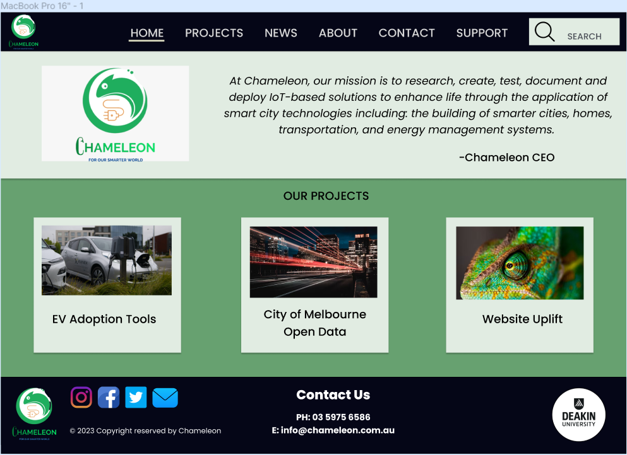

Navbar headers contain links to website components

Footer provides key information and quick links to related sites.

News page provides updates on Chameleon progress and links to articles/blogs related to smart tech.

This page is for potential customers and investors to connect with Chameleon.

Projects page gives overview of Chameleon projects and progress.

Site link included at bottom of summary, i.e. Go to site.

Sponsor Logo’s (bottom right corner).

Project tiles that when clicked on expand to include project summary.

Search bar with basic functionality (optional).

Update Logo’s with Jon’s new design.

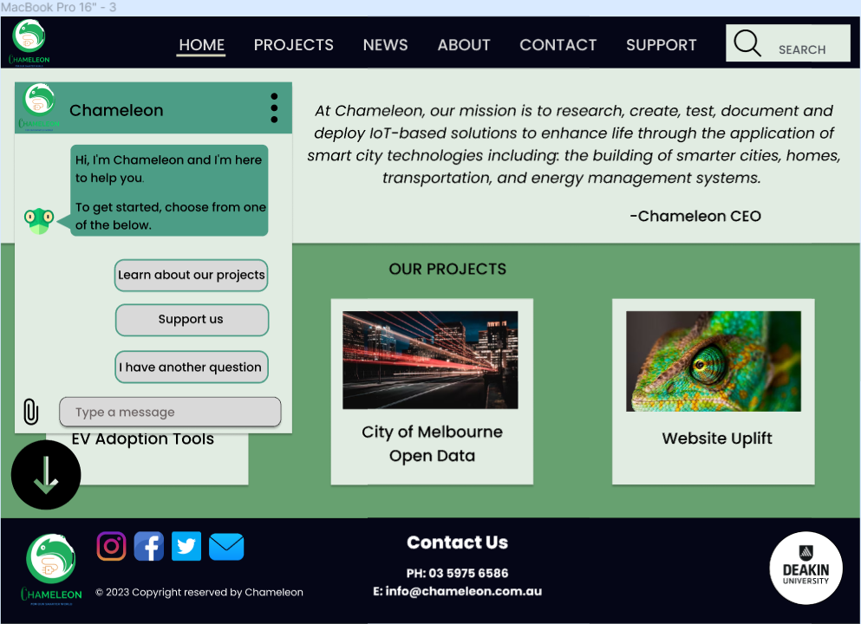

Button to minimise Chameleon chatbot.

Optional chatbot with pre-filled questions and links.

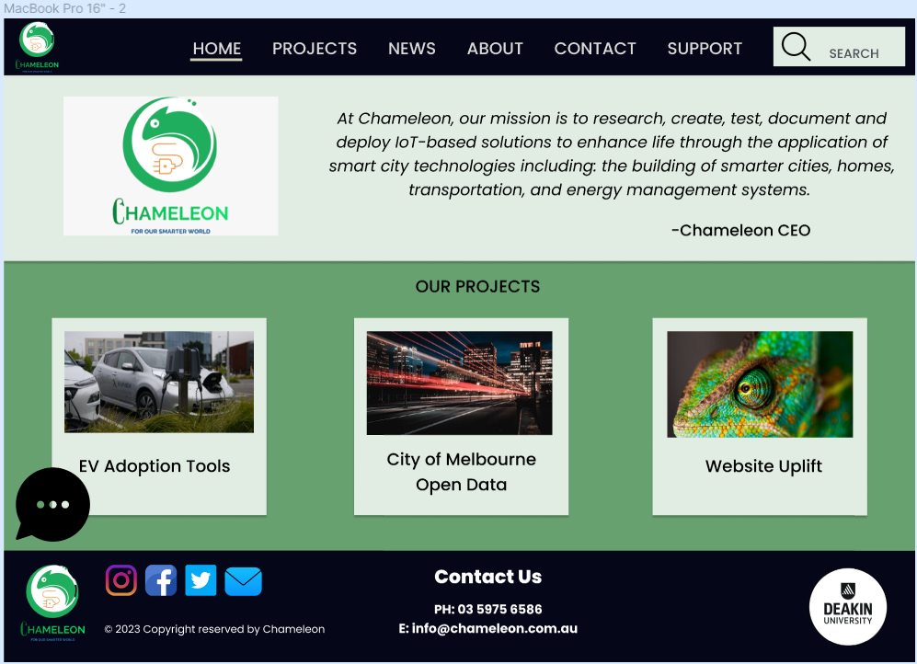

Button to maximise Chameleon chat.